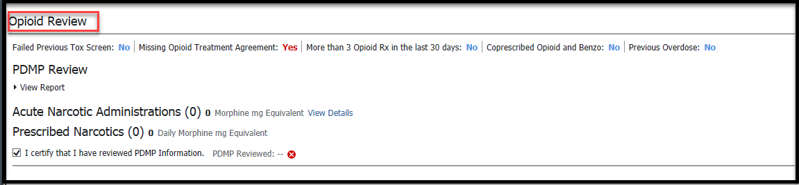

Opioid Review component will display.

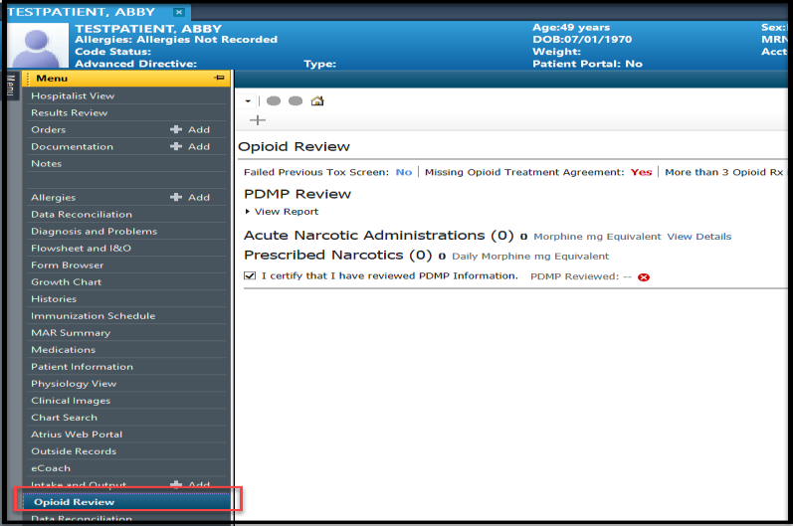

Opioid MPage – PDMP Report

Gain the ability to review the new Opioid Review MPage and run the Prescription Drug Monitoring Program (PDMP) Report via PowerChart prior to submission of narcotics, sedatives or stimulants. **NOTE**: If patient is not found, check your patient opioid prescription review via your State PDMP.

1.

In the patient chart, Select **Opioid Review** from the Table of Contents.

2.

3.

Top of Opioid Review MPage displays 5 fields. See below details.

1. Failed Previous Tox Screen: Failed Tox Screen results are based on only Cannabis and Cocaine. (TBD)
2. Missing Opioid Treatment Agreement: Header will be hidden by default
3. More than 3 Opioid Rx in the last 30 days: Based on Cerner prescribed Opioids.
4. Coprescribed Opioid and Benzo: Based on Cerner prescribed Opioids and Benzos
5. Previous Overdose: Based on previous diagnosis.

Opioid Review MPage

OPIOID REVIEW MPAGE – PRESCRIPTION DRUG MONITORING PROGRAM

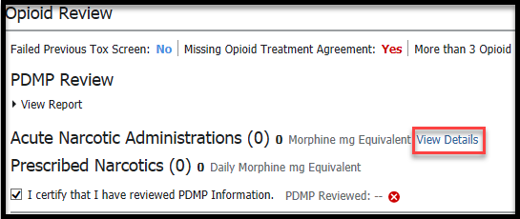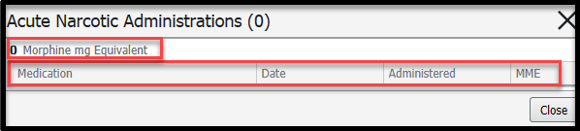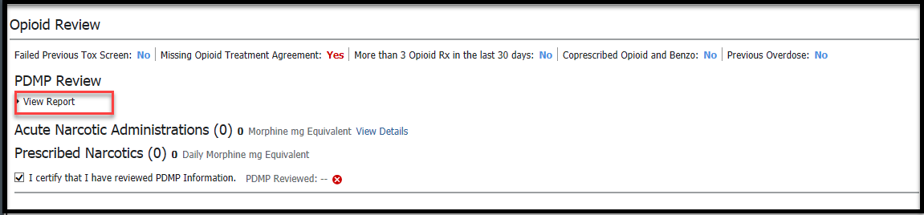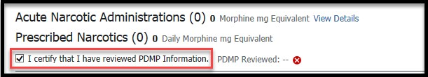

Opioid MPage – PDMP Report

4.

Select **View Details** to display Acute Narcotic Administrations**.**

1.

On the Opioid Review MPage select **View Report**.

2.

**I certify that I have reviewed PDMP Information** is automatically checked off once View Report is selected.

Run PDMP Report

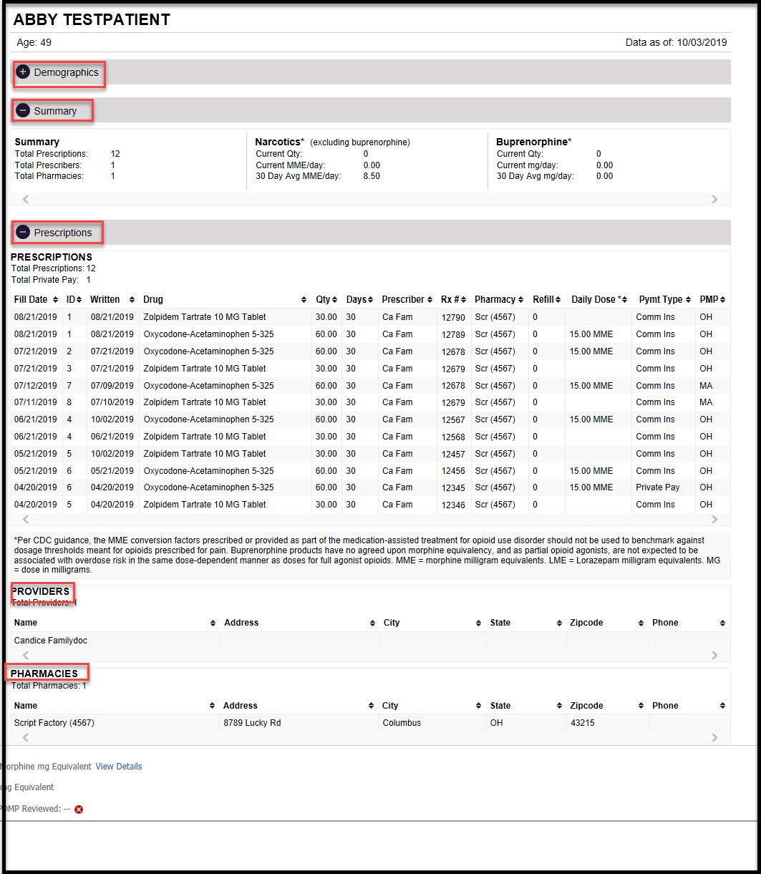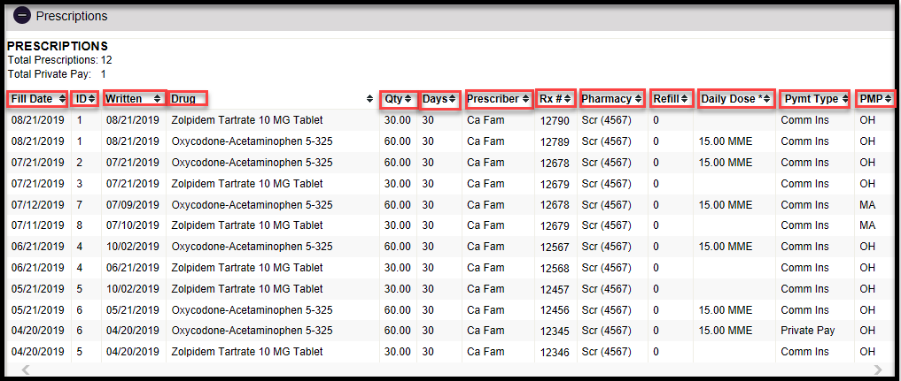

Opioid MPage – PDMP Report

3.

Report displays with 5 Sections, open sections by selecting

icon.

a.

b.

c.

d.

e.

Demographics Summary Prescriptions Providers Pharmacies

4.

Prescriptions Sections pulls each prescription displaying **Fill Date**, **ID**, **Written** (Date), **Drug** (Name and dose), **Qty**, **Days**, **Prescriber**, **RX#**, **Pharmacy**, **Refill**, **Daily Dose** (MME) **Pymt Type**, and **PMP** (State that provided the prescription details).



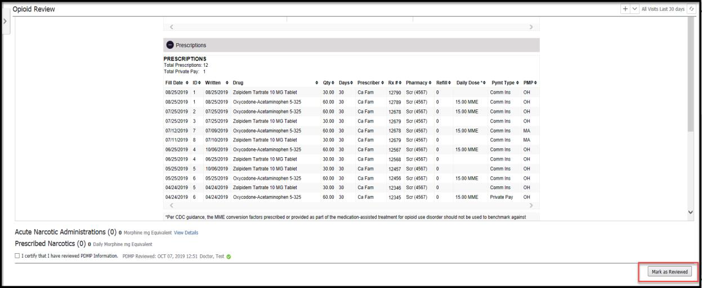

Opioid MPage – PDMP Report

5. After report fully reviewed, select **Mark as Reviewed**.

6. Date, Time and Provider will be recorded for reporting.